This is the absolute last call for tshirt orders.
We currently only have 10 orders and the company requires a minimum of 15 to send in our order.
Dear Families,
This year our class will be creating a unique class shirt featuring drawings made by each student. This t-shirt will be a great for your child to have as a keepsake of their Kindergarten year for many years to come. Parents can also order shirts---great to wear at school activities.
About the shirts…
They will be white with blue ink. The front of the shirt will have the name of the school, my name, and the year. EACH CHILD WILL HAND DRAW A FACE PORTRAIT OF THEMSELVES AND WRITE THEIR NAME UNDER THEIR PICTURE! We will wear the shirts on field trips, special class days, end of year field day, etc.

If you want to order a shirt for your child, (parents can order one too!) please fill in the information below and return the form along with payment by Monday, January 30th.

PLEASE NOTE: This is a ONE TIME offer. These shirts are screen printed and individual shirts cannot be ordered once we send our order in.
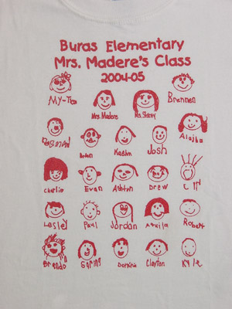
SAMPLE

Please send cash or a check made out to Ashley Jones

Student _____________________Teacher__________________

Total number of shirts ordered ____

Total paid $________

Youth Sizes
$13.00
__ XS (2-4)
__ S (6-8)
__ M (10-12)
__ L (14-16)
__ XL (18-20)
Adult Sizes
$15.00 $17.00
__ Small __ XXL
__ Medium __ XXXL
__ Large
__ X-Large

